HBASE mirror url : <http://apache.mirrors.hoobly.com/hbase/stable/hbase-1.2.5-bin.tar.gz>

**PART I. HBASE Standalone Mode**

Successfully downloaded hbase tar from mirror site

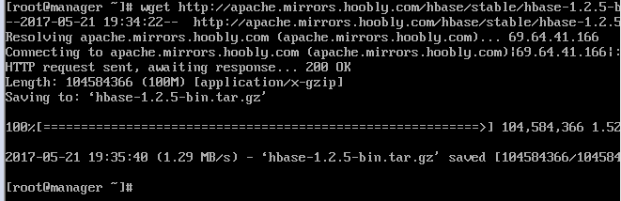

Successfully changed directory to cd hbase-1.2.5/

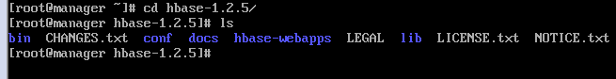

Successfully edited hbase-site.xml

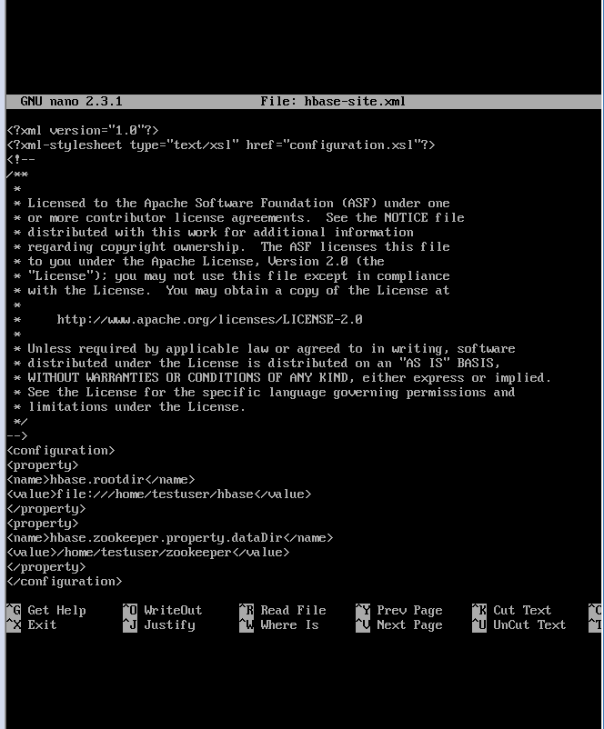

Succesfully started hbase – ./start-hbase.sh

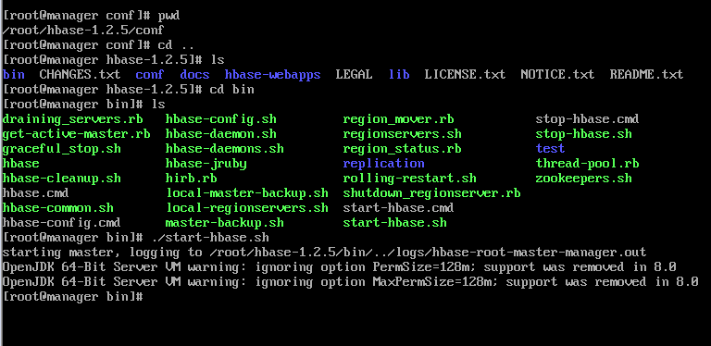

Started HMaster process

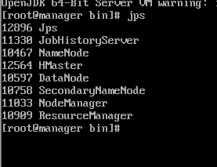  
Successfully started HBASE Shell

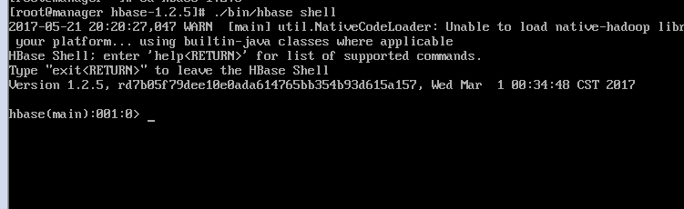

Created test table

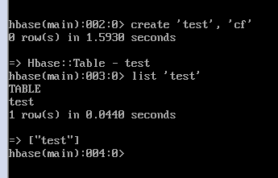

Populated table with values

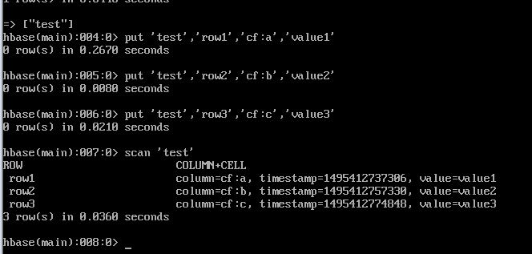

Disabled and dropped table

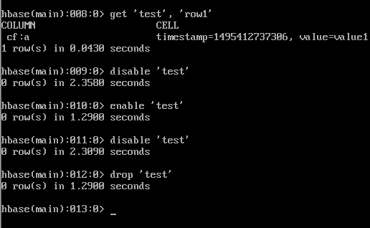

Stopping hbase

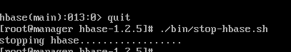

**PART II. Pseudo Distributed Mode:**

Successfully edited hbase-site.xml

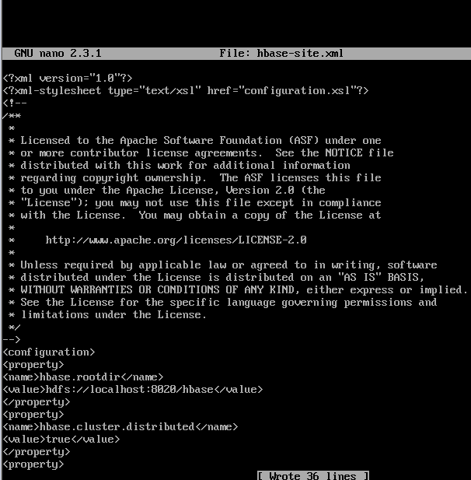

Starting HBASE

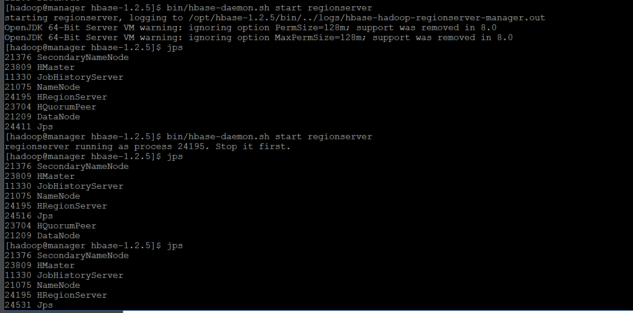

Created table in hbase pseudo distributed mode

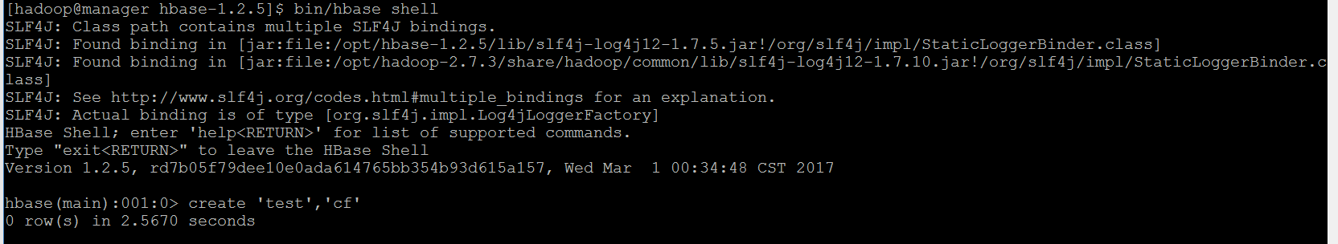

**PART III. HBASE fully distributed mode:**

Conf/regionservers file edited with cluster node names.

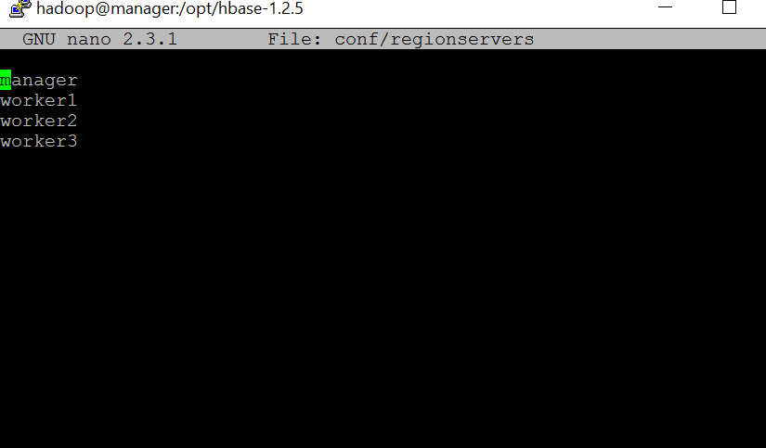

Secure copy of hbase directory to worker1, worker2, worker3 nodes /opt directory

Changed owner to Hadoop from root

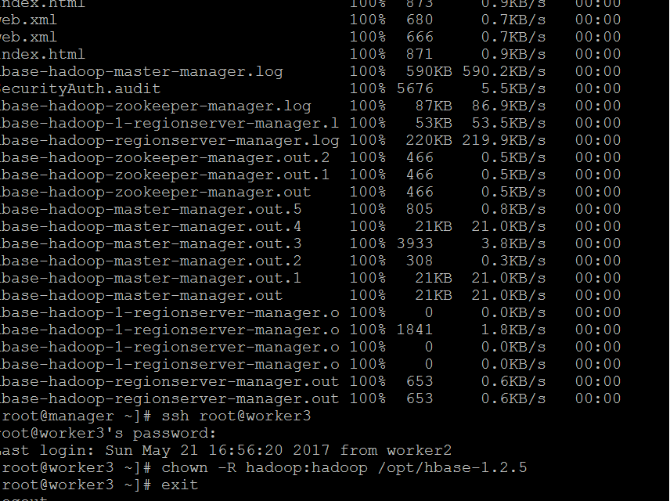

Stopped hbase processes on manager

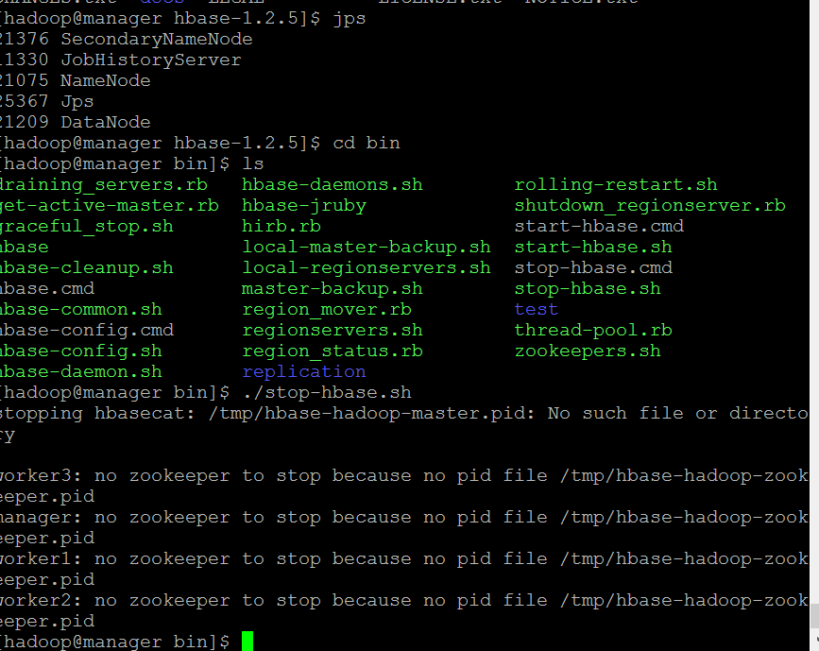

Started hbase distributed on manager node

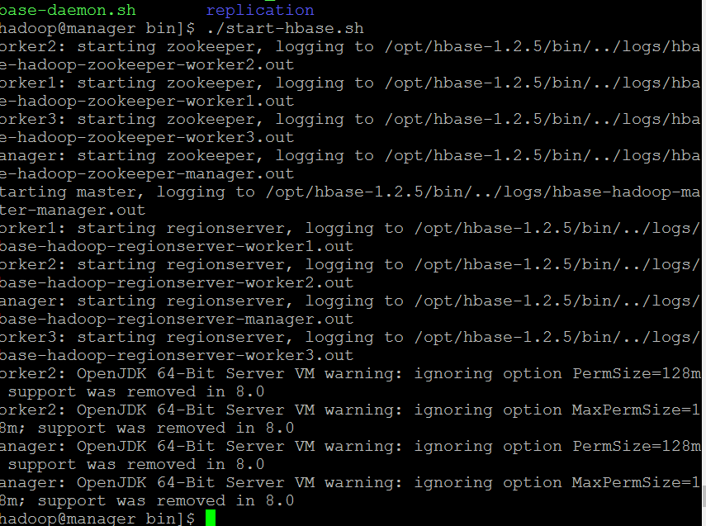

Jps check on manager node

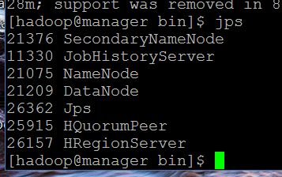

Jps check on worker nodes

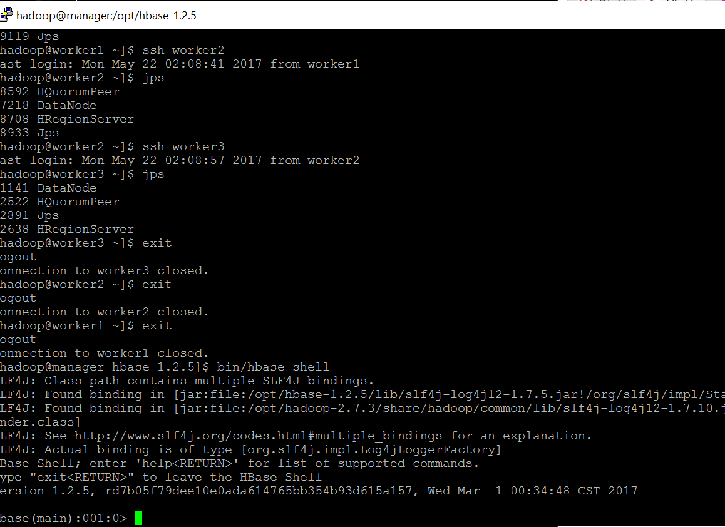

Shell Exercises

HBase create and list table test1

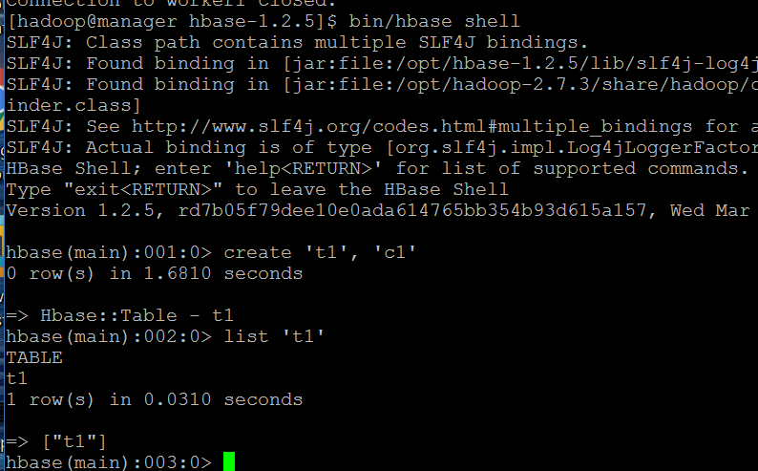

Adding values to test1 table

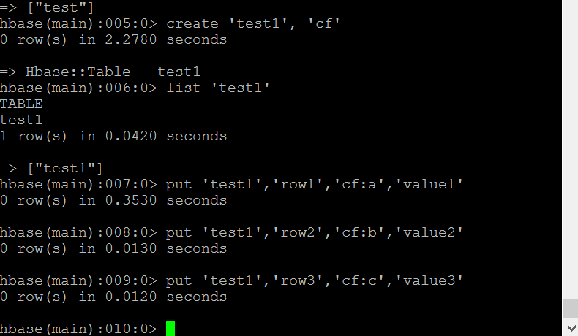

Get test 1 row 1, row2, row3

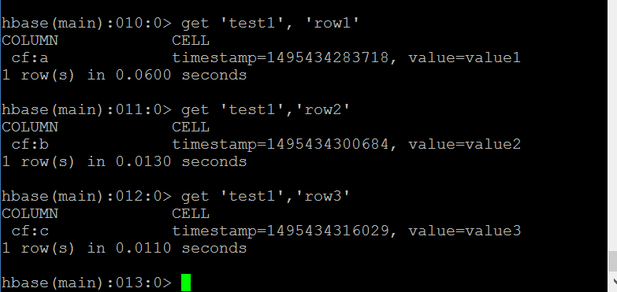

Disable and enable test1 table

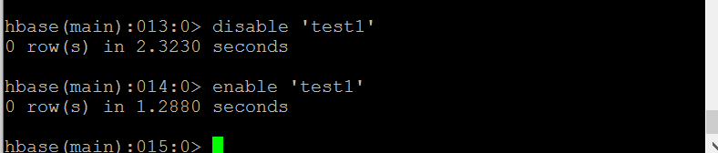

Disabling and Dropping test and test1 tables

